Lesson Plan Format Guidelines:

Paper Size: A4 (8.3 x 11.7 in / 21.0 x 29.7 cm); or
Letter (8.5 x 11.0 in / 21.6 x 27.9 cm) (US’ standard)
Margin: Top – 1 in / 2.54 cm Bottom – 0.5 in / 1.27 cm
Left – 0.5 in / 1.27 cm Right – 0.5 in / 1.27 cm

Front Size: Mark Pro & Mark Pro Medium
Title (e.g. Lesson 4 Visualizing the Global Warming) – 18 points Mark Pro Medium, Bold Added
Heading (e.g. Objectives/Activities/Section 1 Introduction/…) – 14 points Mark Pro Medium, Bold Added
Sub-heading (e.g. Procedure/Step 1/…; headings within the main content) – 11 points Mark Pro Medium, Bold Added
Main content – 11 points Mark Pro
Bold added for emphasis when necessary
Indentation: not for the main content
Line Spacing: 1.5 lines (or 22 points at least)

Spelling and punctuation:
American English and rules for North America
British English and rules for the Commonwealth, and the EU

Use endnotes rather than footnotes
Works cited: Harvard reference, cf. https://www.imperial.ac.uk/admin-services/library/learning-support/reference-management/harvard-style/

Delivery: PDF


Lesson 4:
Seeing with sound

Subject: STEAM Grade(s): 5th and up
Duration: 45 Minutes Difficulty: Beginner

 Lesson Objectives
By the end of this lesson, students will know:
- What ultrasound is and how a sensor based on ultrasound works
- Applications of these sensors in everyday live and in robotics
Overview
Autonomous robots need to be aware of their surroundings when driving unattended to avoid any collisions with obstacles or persons. This also applies to the mBot2. The mBot2 has a specific sensor for this at the front. It is called the ultrasonic sensor and it enables the robot to detect objects in its path using sounds that humans can’t hear – giving it the name (ultrasound).

 Focus
By the end of this lesson, students will be able to:
- Use an ultrasonic sensor for range and obstacle detection
- Make the mBot2 react to obstacles and avoid them in driving

 Pre-lesson Checklist
What do you need?
- PC or laptop (with USB output) with the mBlock software installed, the web version (also for ChromeBook), or a tablet with the mBlock app installed
- The mBot2 with a CyberPi
- A USB-C cable or Makeblock Bluetooth dongle
- Small obstacles (minimum size is 10x10x10 cm)
- A workspace of at least 1m² where the mBot2 can drive

 Lesson plan
This lesson consists of four steps and takes a total of 45 minutes.
Duration | Contents
5 minutes | 1. Warming up  - Ultrasonic sensors in everyday life  - How does an ultrasonic sensor work?
10 minutes | 2. Hands-on  - Getting to know the different code blocks of the ultrasonic sensor.  - Recreating and testing some programming examples of the ultrasonic sensor.
25 minutes | 3. Trying out  - Writing your own program for the robot.
5 minutes | 4. Wrap-up  - Showtime: show what you did with your robot in a fun, short movie for later discussion.  - If your teacher allows, share the end result on social media with the hashtag #mBot2  - Reflection: What are you most proud of? What would you like to improve about your robot?

 Activities
1. Warming up
(5 min)
Step 1: Warming up
This step consists of two parts:
- Ultrasonic sensors in everyday life
- How does the ultrasonic sensor work?

1. Ultrasonic sensors in everyday life
Ultrasound is sound with a very high frequency. So high, that people cannot hear it. With special microphones this sound can be recorded and displayed on a computer: it seems like vibrations in the form of a wave. Since ultrasound has a very high frequency, the waveform shows valleys and peaks very close together. Ultrasound can be a useful thing. For example, you can use the vibrations of the ultrasound to clean objects, or you can also use it to detect objects.

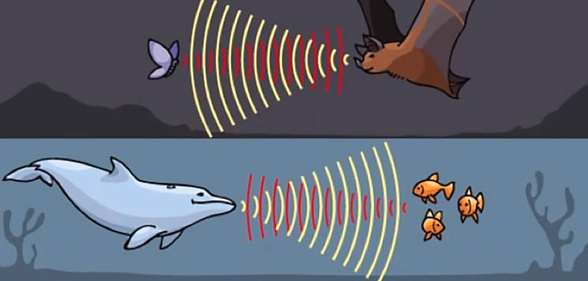
Dolphins and bats use ultrasound this way. They emit an ultrasonic sound, like a short scream. When this sound bounces off something they catch with their ears the vibrations (echo) that come back. This is how they know where other animals are, for example, or if an obstacle is in their way. The radar we have today uses the same principle, but with radio waves instead of sound.
Figure 2. Example of bat and dolphin

2. How does the ultrasonic sensor work?
The mBot2 has an ultrasonic transmitter and a receiver. These are located on the front of the mBot2 in the little cylinders that can be considered as “eyes”. This sensor sends out short bursts of ultrasonic sounds and listens for any echo. Does the mBot2 come close to an obstacle? Then the ultrasonic sound is reflected back to the mBot2. Based on the time it takes for the sound to return to the sensor, the mBot2 internally calculates the distance to it.
This data can be used to decide how the robot should react: you tell it to the robot by programming it. Such an action could be, for example, that the mBot2 should stop driving or make a turn.
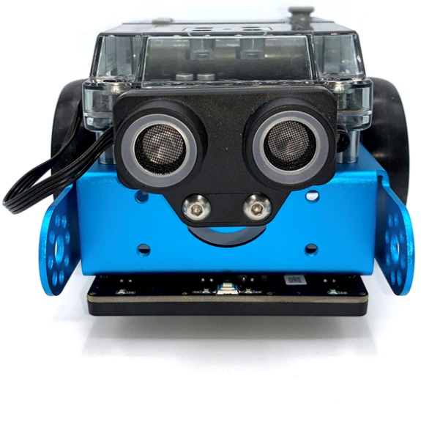
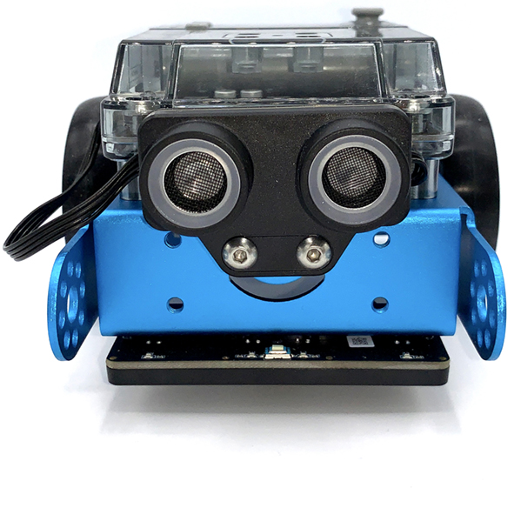
2. Hands-on
(10 min)
Step 2: Hands-on
This step consists of two parts:
- Getting acquainted with the different code blocks of the ultrasonic sensor
- Recreating and testing some programming examples of the ultrasonic sensor.

1. Getting acquainted with the different code blocks of the ultrasonic sensor
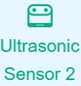
In mBlock, there are several code blocks for the ultrasonic sensor you can use in your programs. For this, you need to add the extension 'Ultrasonic Sensor 2' from the extension library. Then you will find the code blocks in the 'Ultrasonic Sensor' category of the blocks field in mBlock. These code blocks are green.

In the table below, you can see some examples of the code blocks to program the ultrasonic sensor.
Code block:


With this code block you measure the distance between the sensor and an obstacle. The sensing range is between 3 and 300 cm. You can use the value of the distance to make the robot perform a certain action. For example, you can prevent the mBot2 from colliding with obstacles.
In the programming example below, the mBot2 drives forward. When the mBot2 is less than 10 cm from an obstacle, the robot makes a 90 degree turn to the left. Then the mBot2 drives forward again.

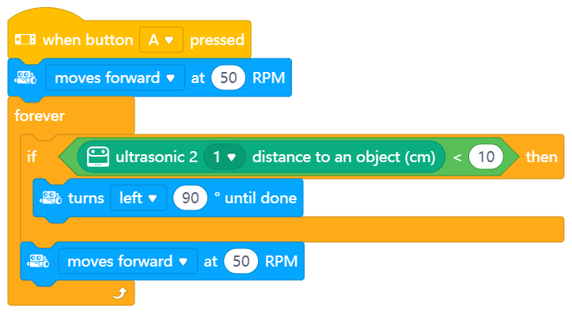

Code block:
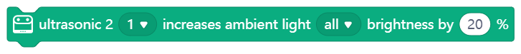

The Ultrasonic sensor on mBot2 has eight blue LED lights. You can use these lights to have the mBot2 show a certain “emotion”, for example, or as a general visual non-verbal communication. Make the LED lights shine very brightly when the mBot2 is happy and less brightly when it is gloomy. There is a specific code block to show pre-defined “emotions”, too. In the image below you can see where exactly the LED lights are located.
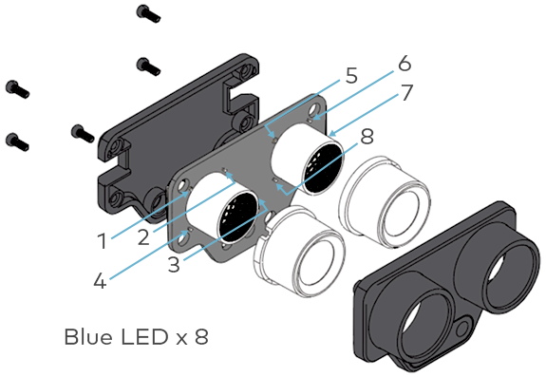

In mBlock there are several code blocks that allow you to program the brightness of the LED lights: you can either set the brightness of the LEDs by decreasing or increasing the brightness by a certain percentage. Or you can set the brightness directly to a specific percentage. The range is 0% to 100%. Both can be done either for a single LED or for all at the same time. In the programming example below, the brightness of the LED lamp 1 is increased by 50%.
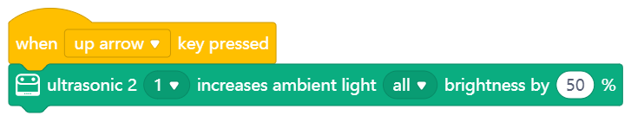

2. Recreating and testing some programming examples of the ultrasonic sensor
In the table above, each code block of the ultrasonic sensor has a programming example. You are going to recreate these programming examples in mBlock and test them. For one programming example, come up with your own ideas on how to extend the application.
3. Trying out
(25 min)
Step 3: Trying it out
You have already learned a lot about the ultrasonic sensor on the mBot2. You are now going to create your own computer program in mBlock using the ultrasonic sensor.
In this assignment you are going to make the mBot2 drive in infinite 'rounds'. You do this by placing an object at each vertex. You program the mBot2 in such a way that it makes a turn at each object and eventually returns to the starting point. Take a look at the image below.
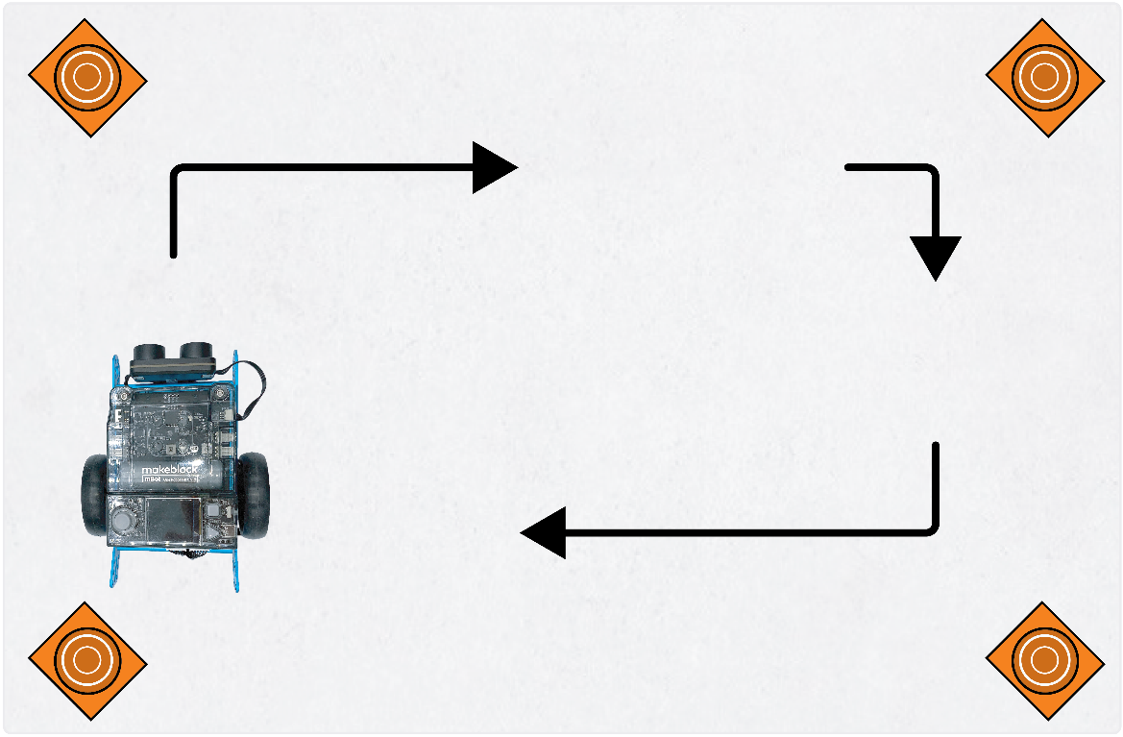

Use the knowledge you gained in 'Step 2' of this lesson. Of course, you can also experiment with the different programming possibilities in mBlock.
In working out this assignment, it is helpful to use the following step-by-step plan. Do you have an idea of what you want to make? If so, first discuss with your teacher whether this is feasible.

 | Explanation
Step 1: What do you want to do? | - In what way should the mBot2 move?
Step 2: What do you need? | - What do you need in addition to the mBot2?
Step 3: What code blocks do you need to make the mBot2 move? | - How can you make the mBot2 change direction at each corner?  - What code blocks do you need to do this?  - Make a brief description on how your program works (pseudocode/natural language, flowchart or UML)  - If you need further explanation, you can discuss with your fellow students, the teacher, or do a research on the topic. There is help available for every coding block in mBlock as well
Step 4: Testing and implementation | - Is the first version ready? Test it! During the testing round, write down points of improvement  - Work on the improvement points until your mBot2 runs error-free over your course  - Successful? Film the end result and ask your teacher if you can post it on social media with the hashtag #mBot2

4. Wrap-up
(5 min)
Step 4: Wrap-up
Did you manage to get the mBot2 to drive one round?
In this lesson, you learned about ultrasonic sensors and where you might encounter them in everyday life. You know how to program the ultrasonic sensor of the mBot2, for example, to prevent the mBot2 from driving into obstacles. You also know how to use the LED lights in the Ultrasonic sensor to make the mBot2 show a certain emotion.
It is now time for a brief reflection. Think on your own and discuss with the group:
- What do you think turned out well?
- What could be better?
- Which parts of the lesson did you find easy and which did you find more difficult?
- What would you like more explanation about?
- Who could help you with that?

